Role of Remote Sensing and GIS Techniques in Urban Planning and Environmental Management :Special Reference of Rohtak District
Dr. Divya Parashar
Assistant Professor
Dept. of Geography
Abstract
The area of Rahtak has undergone rapid urbanization and tremendous economic growth during last decades. Most of the economic development activities are focused in and around Rohtak area. These have rapidly transformed area from a subsistence agrarian economy into rapidly industrialized area. The growing urbanization in the outer periphery of Rohtak area has created pressure for the changes in the land use pattern. In this paper has been described that how to Remote sensing and Geographic Information System (GIS) techniques useful for measuring change detection of particular area.

Climate change and growing population is the major drivers for modification of the land resource and play a principal role in spatially and temporally changes in land use patterns and Environmental phenomenon. Apart from climate change anthropogenic actives such as deforestation, over exploitation of natural resources , rapid urbanization ,impact of pesticide and other human influences have significantly changes is important in global change research. Although, land cover has of quantifying the changes globally.
In ancient period urban settlements originated and then developed with considering changes in social, political religious and historical condition, Specific settlement get benefit from location climate, relief, soil and water supply etc. Some settlements have the central place or nodal place and some settlements are located along the road sides and under this system also planned the Environmental management. These settlement naturally get the facilities like health, plenty water, suitable land for settlement and protectable relief from the surrounding area.
Rapid urban development and increasing land use changes due to increasing population and economic growth is being witness in India and other developing

Countries. The measurement and monitoring of these land use changes are crucial to understand land use dynamics over different spatial and temporal scales. Today, with rapid urbanization there is increasing pressure on land particularly in the metropolitan cities The cites are extended in all direction resulting in large scale urban sprawl and changes in urban land use. Urban sprawl may be defined as the scattering of new development on isolated tract, separated from other areas by vacant land .The spatial pattern of such changes is clearly notices on the urban fringes or city peripheral rural area, than in the city centre. This made the fringe area of the city to be most dynamic landscape.
Remotely sensed data is most important data source for the Environmental changes study over the past many years. Since large collections of remote sensing imagery have been acquired in a time frame of successive year, it is now possible to study long-term Spatial-temporal pattern of environmental changes and impacts of human activities.
In the urban environmental natural and human-induced environment and human health. The study of land use/land cover (LU/LC)changes is very important to have proper planning and utilization OF natural resource and their management.
Remote sensing :
Remote sensing is an art and science by which we can obtain information about area, object and phenomenon without going and touching area, object and phenomenon.
In another term, remote is the acquisition of information about an object or phenomenon without making physical contact with the object and thus in contrast to on site observation.
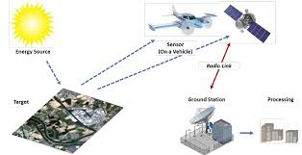

Stage of Remote senssing:
- Emission of electromagnetic radiation ,or EMR (sun/self-emission)
- Transmission of energy from the source to the surface of the earth, as well as absorption and scattering.
- Interaction of EMR with earth’s; reflection and emission.
- Transmission of energy from the surface to the remote sensor.
- Sensor data output.
- Data transmission, processing and analysis.

Geographic Information System:

Geographic Information system (GIS) is a system designed to capture, store, manipulate analysis, manage and present all type of spatial or geographic data. The acronym GIS is sometimes used for geographical information science or geospatial
Information studies to refer to the academic discipline or career of working with geographic information system and is a large domain within the broader academic discipline of Geo-informatics.

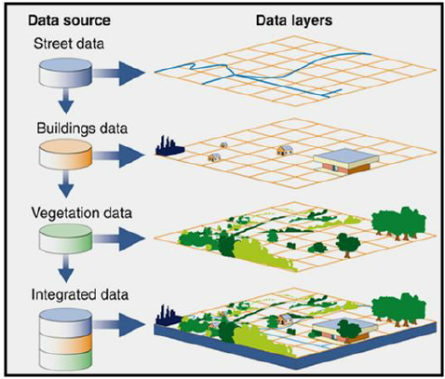

Role of Remote Sensing and Geographic Information system :
The 19th century witnesses a trickle of urbanization and the emergence of metropolises. Control the word’s urban development as crucial for future of humankind. This rapid and haphazard growth of urban sprawl and increasing population pressure is resulting in loss of productive agriculture land and loss of surface water bodies, green open spaces, besides causing air pollution, health hazards and contamination of water.
GIS is a powerful set of tools for collecting, storing, retrieving, transforming and displaying spatial data from the real world. It has an ability to assimilate, divergent sources of data both spatial and non spatial. GIS allows the user to integrate database generated from various sources on signal platform and analyze them in a spatiotemporal domain. GIS provides supports in resource management and decision making.
Study Area:
Research Area : Rohtak District is located in central part of Haryana and falls between latitude 28˚40’ 30” to 29˚05’35” North and longitude 76˚13’22” to76˚51’20” East covering an area of 1668 sq.km. The District Rohtak falls in Survey of India Top. Sheet No.53 C and 53 D. It is bordered by Sonipat in the north and north-east , Jind District in the North Jhajjar District .In the South Hisar District in the North –East Bhiwani in the West. The District Head Quarter is Rohtak .Due to the Proximity to Delhi; the Development activities are taking place very rapidly.

Methodology:
To purpose of this research, assessment of urban land use change dynamics of Rohtak area a series of remote sensing and spatial analysis methods are implemented form preprocessing images, and their analysis, modeling, and analysis vector data in GIS. Here, The ArcGIS and ERDAS software are used for analyzing of images to show the changes of Rohtak District

NDVI Preparation :
The Normalized Difference Vegetation Index (NDVI)is a calculation, based on several spectral bands, of the photosynthesis output in a pixel in a satellite image. It measures, In effect, the amount of green vegetation in an area. NDVI calculations are based on the principal that actively growing plants strongly absorb radiation in the region of the spectrum(RED band)white strongly reflecting radiation in the visible region. The concept of vegetative spectral signature is based on this principle.

The NDVI for a pixel is calculated from the following formula:
NDVI= NIR-RED / NRI+RED

This formula yield a value that ranges from -1(usually water)to +1(strongest vegetation growth)

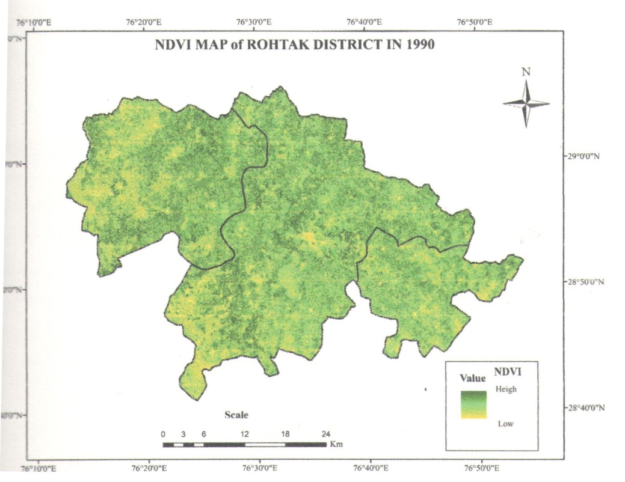

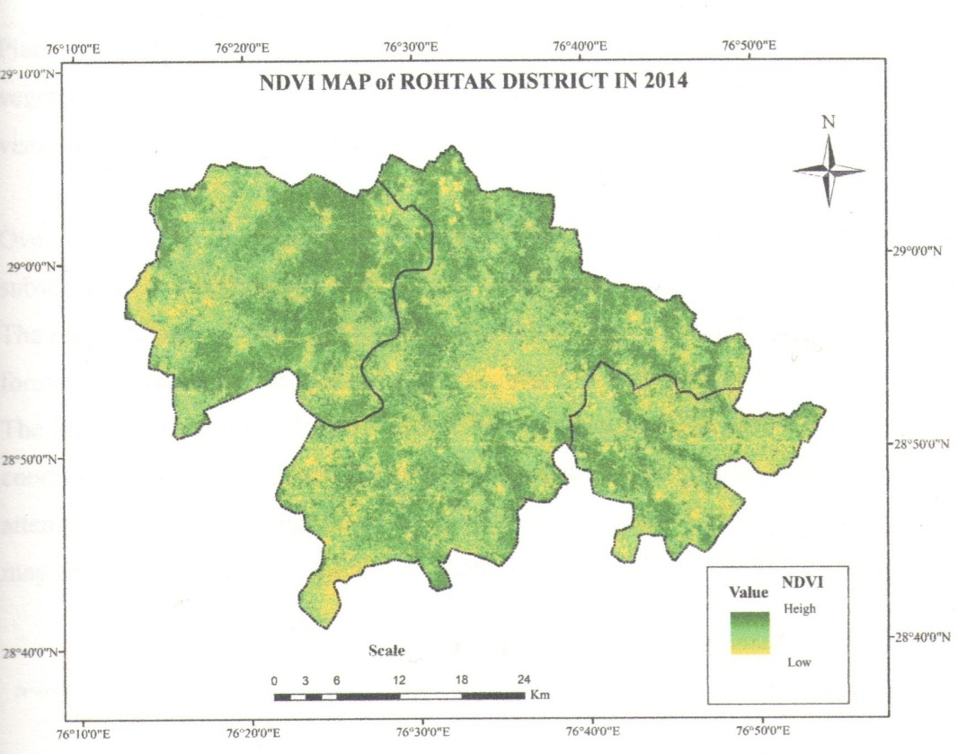

All the sides from the city center between 1990 and 2014 as shown in fig. of change detection layer, there exist drastic reduction in the spatial expansion of the city. The only noticeable growths are on the edges of the developed areas of 1990 built-up land. For the project change as shown in Map of change detection layer which are laying between 1972 and 1990, the edges of built-up land seems to have been up with developments by2025 leaving only noticeable to areas around the city centre. These therefore suggest that there might be a high level of compactness in Rohtak by 2025.

---------------------------------------------------------------------------------------------------------------

Reference:

Arvind C. Pandy and M.S.Nathawat (2006), Land uses Land Cover Mapping through Digital image processing Of satellite Data – A case study from Panchkula, Ambala and Yamuna agar District, Haryana State, India.
Aruna Saxena (2000). A book of Advance Ecology, Daya Publication House, New Delhi.
Batty, Xie and Sun (1999). A text book of Urban Remote Sensing Monitoring, synthesis and modeling in the Urban Environment.
Behera. et al. (1985). A text book Advance Ecology and Environment Science
Sunar, F. (1998) “An analysis of changes in a multi-data set: A case study in the Ikitelli area,Istanbul,Turkey”, International Journal of Remote sensing, vol. 19,no. 2 pp.225-235.

